Project Documentation

Rules & Regulation (SDLC) Software dev life cycle
Six rules
- Requirement

- Analysis

Step : 1 Define Total no of user

Guest – website
Customer – website
Employee - emp panel
Admin - Admin panel

===============================================================

Step : 2 Define each module task

Guest
View categories
View products
Contact us

Customer :

View categories categories.tbl
View Products products.tbl
Contact us contact.tbl
Signup customer.tbl
Manage profile customer.tbl
Login customer.tbl
Manage booking / add /upd/del/ view booking.tbl
Feedback feedback.tbl
Logout customer.tbl

Emp :
Signup with admin employee
Login employee
Manage Customer customer
Manage categories / add /upd/del/ view categories
Manage services add /upd/del/ view services
Manage Contact us contact
Manage booking / view booking
Logout employee
Admin :
Login admin
Manage Customer customer
Manage Emp / add /upd/del/ view employee
Manage categories / add /upd/del/ view categories
Manage products add /upd/del/ view products
Manage Contact us contact
Manage booking / view booking
Manage Feedback feedback
Logout admin
=====================================================================================

Step 3: Define DFD
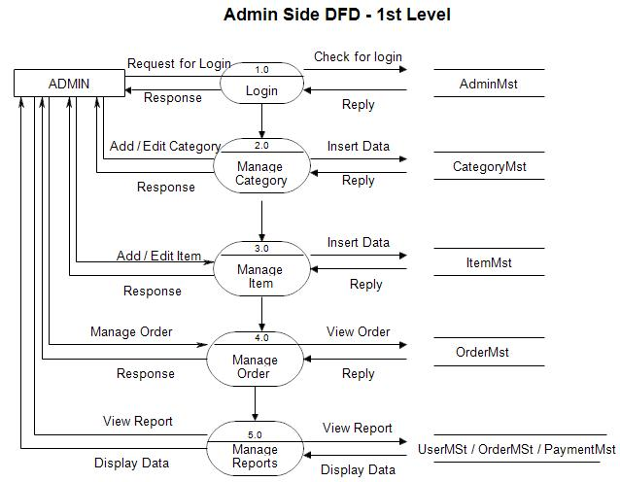

Step 4 : Define all table list

employee
customer
categories
services
contact
booking
admin
feedback

step 5 : Define each table column / form input type

employee table 6 / form input 5

id pk auto_increement
name
email
password
mobile
img
status default Unblock

customer

id pk auto_increement
name
email
password
mobile
img
status default Unblock

categories

id pk auto_increement
cate_name
cate_img

services

id pk auto_increement
cate_id fk
service_name
service_desc
price
service_img

contact

id pk auto_increement
name
email
comment

booking

id pk auto_increement
cust_id fk
service_id fk

admin

id
name
email
password

feedback
id pk auto_increement
booking_id
cust_id
comment

=====================================================================================

- Designing table designing in database / create page & form in all panel
- Coding / implementation
- Testing
- Maintenance

